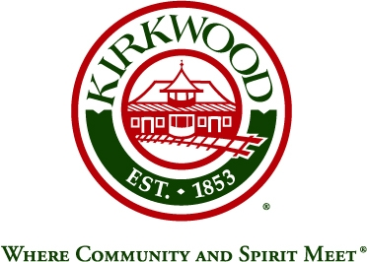

**KIRKWOOD CITY COUNCIL – VISION ZERO TASK FORCE**

**AGENDA**

**VIA ZOOM (SEE DETAILS AT BOTTOM)**

**139 SOUTH KIRKWOOD ROAD**

**April 20, 2021**

**8:30 A.M.**

# I. INTRODUCTIONS

# II. VISION ZERO ACTION PLAN BACKGROUND AND PURPOSE

###### III. PROJECT EXPECTATIONS AND DESIRED OUTCOMES

###### IV. CONSULTANT SCOPE REVIEW

###### V. PROJECT SCHEDULE

**VI. CONSULTANT INFORMATION AND DATA NEEDS**

**VII. NEXT STEPS**

**VIII. ADJOURNMENT**

Please click the link below to join the webinar:

<https://zoom.us/j/91539951392?pwd=dDRzd21HZ3hpcEoyLy9SRDNRZzYrUT09>

Passcode: 183308

Or One tap mobile :

US: +13126266799,,91539951392#,,,,*183308# or +16468769923,,91539951392#,,,,*183308#

Or Telephone:

Dial(for higher quality, dial a number based on your current location):

US: +1 312 626 6799 or +1 646 876 9923 or +1 301 715 8592 or +1 253 215 8782 or +1 346 248 7799 or +1 408 638 0968 or +1 669 900 6833

Webinar ID: 915 3995 1392

Passcode: 183308

International numbers available: https://zoom.us/u/aq0Q6vbaV

The City of Kirkwood is interested in effective communication for all persons. Persons requiring an accommodation to attend and participate in the meeting should contact the Public Services Department at (314) 984-5926 at least 48 hours before the meeting. With advance notice of seven calendar days, the City of Kirkwood will provide interpreter services at public meetings for languages other than English and for the hearing impaired. Upon request, the minutes from this meeting can be made available in an alternate format, such as CD by calling (314) 984-5926. Agendas and approved minutes are available on the City’s web site at [www.kirkwoodmo.org](http://www.kirkwoodmo.org).