

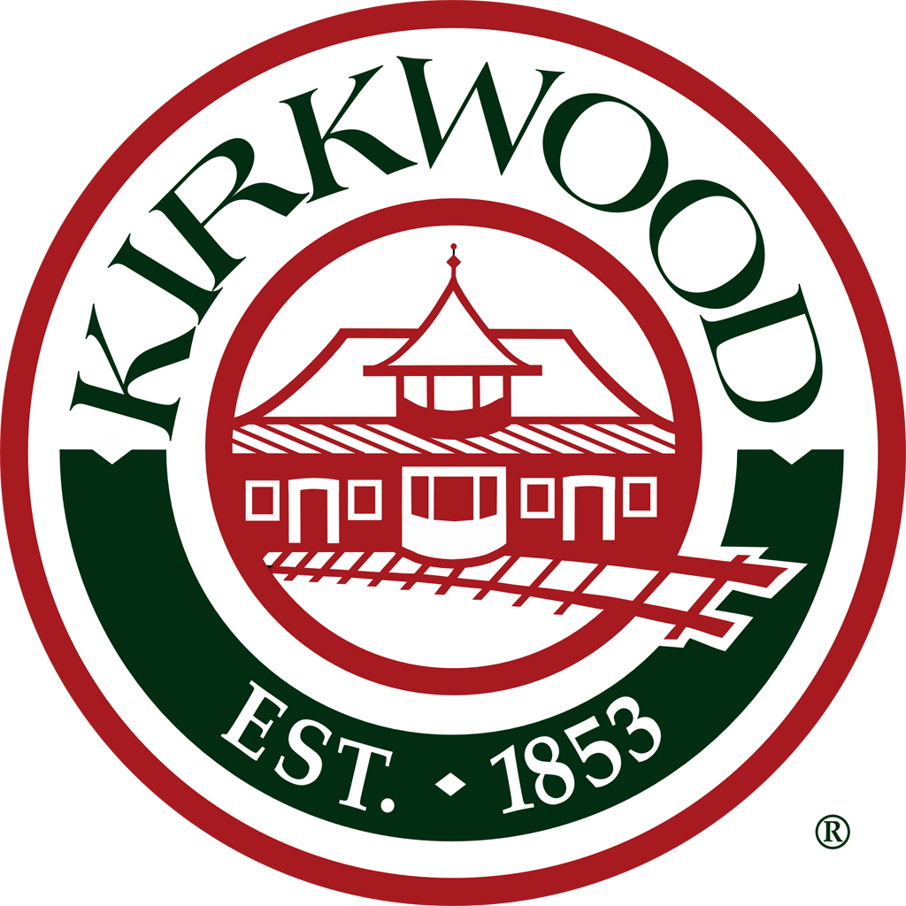

Special Meeting of the Greentree Festival Committee: In attendance (via ZOOM): Bob Mosby, Linda Ross, Liz Gibbons, Mary Loida, Gerry DeWulf, Kate Zisser, Kyle Henke, Pat Jones, J.T. Wiley, Peggy Childress, Meg Lauber, Fred Doss, Joe Walsh, Debbie Zisser, Debbie Stream, Cindy Coombs, Matt Barthelmass, April Barthelmass, Bill Burkhalter, Katie Burkhalter, Alvin Reid, Gary Baldridge. Meeting called to order by Bob Mosby at 7:00 p.m.

1. **Party on Your Porch, September 18, 2020.** The bands travelling through Kirkwood on what would have been the traditional opening night for the Greentree Festival was a great success. Everything went well despite the little time available to organize the event. Many residents saw it as a morale builder during the COVID pandemic. The Committee will explore the possibility of incorporating travelling bands as part of the Greentree Festival. This event might be better suited during the summer as a lead-up to the Greentree Festival, rather as part of the actual festival or as a replacement for the annual Party in the Park. The Committee will need to secure sponsorship money for this event if it wants it to continue. Kirkwood Electric donates annually to the Greentree Festival, but because the festival was cancelled this year, their donation paid for the band-related expenses. The Committee will need to look for other sources of sponsorship to continue this travelling music event.

2. **Can we have the Greentree Festival in 2021?** The Committee discussed if it was reasonable to plan a Greentree Festival for 2021 with the current COVID pandemic, and at what point will the Committee definitely know if it is or is not possible to hold the festival. Because of the recent positive news on the development of a vaccine, the Committee decided that it should start planning an event, knowing it may need to modify or scale back plans to comply with any future St. Louis County restrictions. The Committee set Wednesday, February 24, 2021, as the first planning meeting for Greentree Festival 2021. The Committee then discussed if it was possible to have in-person meetings in larger rooms while adhering to social distancing guidelines. Under current St. Louis County restrictions, the Greentree Committee cannot meet in person. However, because the rules could change between now and February 2021, the Committee left open the possibility of meeting in person, but is expecting to meet via Zoom.

3. **New Tent and Food Booth Rules**. Per the Fire Marshal of the City of Kirkwood, ALL VENDORS must have a minimum 2A-10B:C portable fire extinguisher inside their tents, and a no smoking sign must be visibly posted in all tents. Vendors must supply their own fire extinguisher; the Greentree Festival will supply the no smoking signs. Regarding food vendors (open flame/cooking appliance): 1. All tents must possess a certificate or label certifying that the tent and all their appurtenances meet the NFPA 701 criteria for flame propagation performance treatment; 2. A minimum 1.5 gallon Class K extinguisher must be available at each tent in addition to the 2A-10B:C extinguisher required for all tents or membrane structures. The extinguisher must be tagged with the inspection date and inspection company. Any extinguisher not tagged will not be allowed. In addition, The Greentree Committee must increase the egress between the food vendor booths and the main walkway, and must allow for a minimum 20 foot space between any structures with cooking devices and parked vehicles ***(please see attachment for further information all new requirements)***. The Greentree Committee will discuss logistics and the layout of the festival to comply with these rules. Further discussion included the possibility of renting or selling fire extinguishers at check-in to vendors who did not bring their own, and if there is a spray on the market that vendors can apply to their tents to make them compliant. Because most festivals have similar requirements, the Committee expects that the vendors will be prepared for the Greentree Festival. In addition, The City of Kirkwood has posted these new requirements on the Greentree Festival website, and they are already part of the vendor application, so vendors should be aware of the new policies before the start of the festival.

4. **Further suggested changes to Greentree Festival 2021.** The Committee is still in agreement that The No Dogs policy should be strictly enforced. Officer Baldridge asked if the police had the authority to enforce that rule, since dogs are allowed in the park during the rest of the calendar year. Kyle Henke agreed to look into this issue. Matt Barthelmass confirmed there is a City of Kirkwood ordinance that gives the Director of Parks and Recreation the authority to enforce the no dog policy on certain occasions, including Greentree Festival. The Committee also discussed the possibility of having a local business sponsor a “Camp” where owners could leave their dogs while attending the festival. It was agreed that this might be a liability issue. The Committee agreed the biggest change to the Festival will be the new layout needed to comply with the fire marshal’s requirements. Specifically, the Committee may need to rent more generators and supply more power outlets for the vendors. In addition, the distance requirements may lead to fewer vendors in 2021. The Committee also agreed to use the 2020 Festival theme for the 2021 Festival. Bob Mosby asked the Committee to recruit other Kirkwood community members to join the Greentree Committee.

5. With no new business to discuss, Bob Mosby adjourned the meeting at 7:45 p.m.