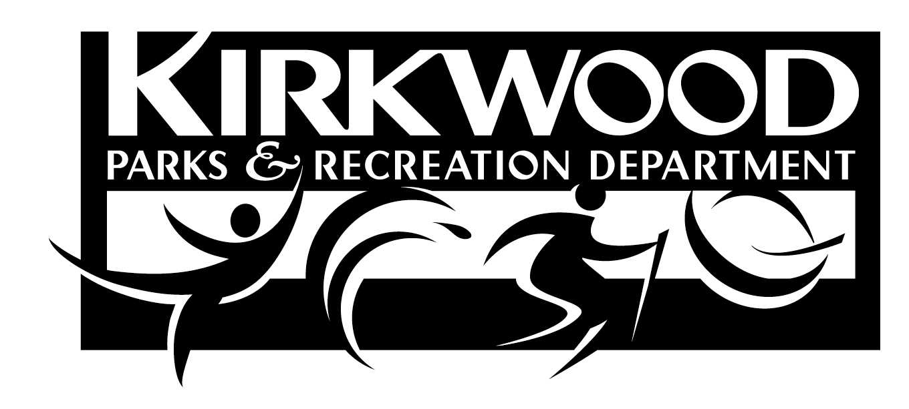
PARC (Participation at Reduced Cost) and Courtney Shupe Scholarship Program
Partner Application Form

Family Name

Telephone ____________

Address City/State/Zip

Email Address______________________________________________________________________________

Please list family members to be included in the PARC and Shupe Scholarship program (Must include at least one family member 17 or under):

Name Date of Birth

Name ________________________ ____________ Date of Birth

Name Date of Birth

Name Date of Birth

Please attach documentation showing your family is eligible for one of the following programs (check all that apply):
Temporary Assistance for Needy Families (TANF) Section 8 Housing
Supplemental Social Security Income (SSI) Aid To Dependent Children Medicaid, MC+ or Medical Assistance for Families Title 1 School Meal Program
Name of person or official who can verify your eligibility through the above program:

Name Agency

Daytime Phone E-mail

I, (name of applicant) give permission to authorize the City of Kirkwood Parks and Recreation Department officials to verify information on this application. I also understand that deliberate misrepresentation of information subjects the applicant(s) to being disqualified for scholarship consideration. I hereby certify that all of the above information is true and correct to the best of my knowledge and belief.

Signature of Applicant Date
Complete this form and return to:
PARC and Shupe Scholarship Coordinator ~ Kirkwood Parks and Recreation Department
111 South Geyer Road Kirkwood, MO 63122 ~ Office: 314-822-5855 ~ Fax: 314-984-5931

~~~~~~~~~~~~~~~~~~~~~~~~~~~~~~~~~~~~~~~~~~~~~~~~~~~~~~~~~~~~~~~~~~~~~~~~~~~~~~~~~~~~~~~~~~

Approved Denied By Date Expires

*The PARC/Shupe Scholarship allows for Kirkwood Resident youth to participate in one (1) free swim or dive lesson session and all other programs at half price. Additionally, the Shupe Scholarship allows for applicant youth and an adult caregiver a season pass at half price. Oakland/Glendale residents will receive the scholarship based on resident status for respective area covered under current municipal agreements. Application is good for two years from the date of approval.

