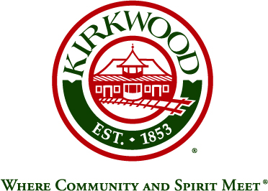
For more information, contact: Beth von Behren
Public Information Officer, City of Kirkwood
139 S. Kirkwood Road, Kirkwood, Missouri 63122
314-822-5894 or 314-495-7382 (cell)

For Immediate Release

City Will Present Proposed Zoning and Subdivision Code
Updates to Residents at Public Meeting December 12

July 31, 2026

Kirkwood, Missouri: The City of Kirkwood began the process of reviewing and updating the City’s Zoning and Subdivision Codes in early 2019, when a steering committee, “Kirkwood By Design,” was appointed. Recommendations developed by the committee and the City’s Consultant will be presented to residents at a public meeting on Thursday, December 12, at Kirkwood City Hall, 139 S. Kirkwood Road.

The formal presentation will begin at 6:00 p.m., and will include a moderated question and answer period, where participants can submit written questions. After the Q&A session, the City’s Consultant along with staff from the Planning Department will be available at designated stations to answer individual questions and hear comments from the public. The public is also welcome to submit emailed comments after the presentation to Jonathan Raiche at raichejd@kirkwoodmo.org.

A final draft of recommendations will be developed with public comments in mind and will be formally presented to the City’s Planning & Zoning Commission. After that, a public hearing will be held by City Council.

###

