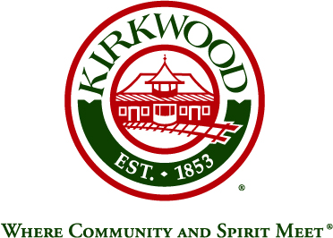
For more information, contact: Beth von Behren
Public Information Officer, City of Kirkwood
139 S. Kirkwood Road, Kirkwood, Missouri 63122
314-822-5894 or 314-495-7382 (cell)

For Immediate Release

City of Kirkwood Moves Forward with Planning
for “Complete Streets”

July 29, 2026

Kirkwood, Missouri: The City of Kirkwood has been selected by the National Complete Streets Coalition, out of large field of applicants, to participate in a series of Complete Streets workshops in 2020. Kirkwood was selected because of its past and current projects as well as its goals for the future. The City described in its application its commitment to “support quality of life through increasing community accessibility and mobility for all modes of transportation (walking, biking, transit, etc.) and all levels of abilities.”

The National Complete Streets Coalition, a program of Smart Growth America, announced earlier this month that Kirkwood, Joplin, and Eastern Jackson County had been selected for the third Complete Streets Consortium workshop series. Following successful Consortia in Tennessee and Colorado, the Coalition announced in a press release that it was “excited to extend this technical assistance program to these Missouri communities with support from the Centers for Disease Control and Prevention and in partnership with the Missouri Department of Health and Senior Services, the Missouri Council for Activity and Nutrition through the University of Missouri Extension, and Missourians for Responsible Transportation.”

The communities will participate in a series of three workshops designed to identify and overcome barriers to implement activity-friendly routes to everyday destinations that make it safe and convenient for people of all abilities to walk, run, bike, skate, or use wheelchairs to reach homes, jobs, shops, schools, and more. The workshops will help the City to meet its goals as outlined in the City’s Pedestrian and Bicycle Plan, the EnVision Kirkwood 2035 comprehensive plan, the recently adopted ADA Transition Plan, and the development of a Vision Zero Action Plan in the coming year.

Over the past several years, Kirkwood has implemented bicycle facilities throughout the City, with installation of 10+ miles of pavement markings such as bike lanes, sharrows (shared cycle/vehicle lane markings), and enhanced pedestrian street crossings. The City also built new sidewalks to fill identified gaps, with a focus on areas near schools.

As part of its focus on accommodating alternative modes of transportation, the City also has partnered with neighboring communities and MoDOT to develop and build a multi-use trail on a reconstructed I-44 bridge that will connect adjacent communities to the greater region by giving trail access across the Meramec River.

“We believe we have made significant strides in overcoming barriers to implement activity-friendly routes to every day destinations,” said Public Services Director Bill Bensing. “We also strongly believe that the Complete Streets Consortium workshop opportunity will allow our elected officials and professional staff to gain more experience and technical knowledge related to making this type of travel safe and convenient for people of all abilities.”

###

