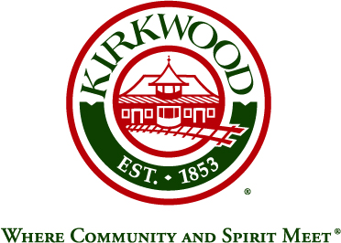
For more information, contact: Beth von Behren
Public Information Officer, City of Kirkwood
139 S. Kirkwood Road, Kirkwood, Missouri 63122
314-822-5894 or 314-495-7382 (cell)

For Immediate Release

Sarah Noonan Appointed as City of Kirkwood Prosecuting Attorney

July 28, 2026

Kirkwood, Missouri: Sarah L. Noonan has been appointed to the position of Prosecuting Attorney for the City of Kirkwood, replacing John S. (Jack) Martin. Ms. Noonan was sworn in on July 29.

Ms. Noonan is a 2009 graduate of Kirkwood High School. She received her J.D. from Washington University in St. Louis School of Law in 2018, where she served as Executive Editor of the Washington University Law Review, vo. 95, and as a member of the National Moot Court team. She received her Bachelor of Science from the University of Kansas in 2013.

Ns. Noonan is an associate with the St. Louis law firm Lewis Rice LLC, practicing employment and commercial litigation and will work closely with the City Attorney John Hessel. Prior to law school, she worked at ISNetworld in Dallas, Texas, a software company.

###

