# https://pbs.twimg.com/profile_images/481601702/city-logo-tagline-r300res.pnghttp://www.stlouislandscape.org/_ccLib/image/users/LOGO-206.jpg

**KIRKWOOD, MISSOURI PARK BOARD**

**&**

**PARKS & RECREATION STAFF**

**STRATEGIC PLANNING & TEAMBUILDING INITIATIVE**

**Adopted By**

**THE KIRKWOOD PARK BOARD**

**MARCH 20, 2017 (Updated March, 2018)**

**FACILITATED BY**

**SYLVAN A. SCHULZ & DAVID M. WHITE**

# PREFACE

The Kirkwood Park Board along with key staff members of the Kirkwood Parks and Recreation Department met on January 28, 2017 to develop a strategic plan and identify specific actions that can be taken to strengthen the organization.

The following focus question was developed:

***What steps can we take as individuals and as an organization to provide quality parks and recreation services to maintain a high level of overall satisfaction by the citizens of Kirkwood?***

|  |  |
| --- | --- |
| **PARTICIPANTS** | |
| **Kirkwood Park Board** | **Kirkwood Parks and Recreation Staff** |
| Scott Stream, President | Murray Pounds, Director |
| Steve Coates, Vice President | Curtis Carron, Superintendent of Parks |
| Wallace Ward, Treasurer | Kyle Henke, Superintendent of Recreation |
| Matt Helbig | David Lavely, Park Foreman |
| Alan Hopefl | Don LaChance, Recreation Supervisor |
| David Hufford | Laura Thal, Recreation Supervisor |
| Kate LeGrand | Ron Hall, Chief Park Ranger |
| Kara Wurtz | Sherry St. Onge, Office Manager |
|  | Peter Laufersweiler, Horticulturist |

The attached document provides direction and an action plan designed to achieve agreed upon visions and overcome obstacles in the path of those visions.

**HISTORICAL PERSPECTIVE**

Beginning in the early 1990s the City of Kirkwood, along with other departments within the city, including the Parks and Recreation Department and Park Board, instituted a strategic planning process. This process provided a platform to build a united vision, goals and vision action plans, and led to outcomes which included but were not limited to:

* The development of a new state of the art aquatic and ice rink facilities
* A reexamination of procedures and policies
* The institution of quantifiable employee performance standards
* The development of methods of benchmarking the services provided
* A united vision between the governing bodies of the city and the employees for the provision of quality services to the residents
* A true sense of teamwork, respect and increased knowledge of roles played by the participants.

The new facilities became a stimulus for a complete rebranding of the parks and recreation department. This new brand not only featured modernized bricks and mortar (and water) but it also showcased the investment the city made to provide state-of-the-art services for its residents.

**CURRENT STATE**

In 2016, the Kirkwood Parks and Recreation Department and Kirkwood Park Board renewed their commitment to facilitated strategic planning. Previous efforts were catalysts for a revitalized department and an increase in favorable public perception and utilization of the services offered. The following factors informed the need for a renewed strategic plan:

* The current strategic plan was outdated (intention of the last plan was to go through 2013)
* Facilitated strategic planning is part of the Kirkwood DNA—to operate with a long-range view and develop aligned plans to deliver outcomes to its residents
* Significant progress had been made in the completion of park developments and enhancements and new and large initiatives are in play that will again provide a “pivot” platform for Kirkwood’s brand.
* Staff and board members have changed so it was time to realign on goals, outcomes, obstacles and tactics to deliver on future plans.
* Strategic planning provided a platform for blended learning to foster newer ways of thinking while also being mindful of long standing traditions that make Kirkwood unique.
* The board and staff were provided an outlet to interact (improving board member touch points).

**PROCESS**

The process used to develop this strategic plan emphasized individual input that was then shared in small group discussion. The groups consisted where possible of an equal number of board and staff members. Areas addressed were visions, contradictions/impediments and upon identification of those items, action plans were developed.

During each portion of the session, the participants were asked to individually compile a list of visions, contradictions and impediments and actions they would like to see the Kirkwood park and recreation system adopt. Upon completion of their individual list, they then broke into small groups of 4 or 5 to discuss their best thoughts. The groups were comprised of both staff and board members thus providing for input from all levels of the organization. The groups then presented their best compilation to the other participants. The results were then grouped per similarity or thrust.

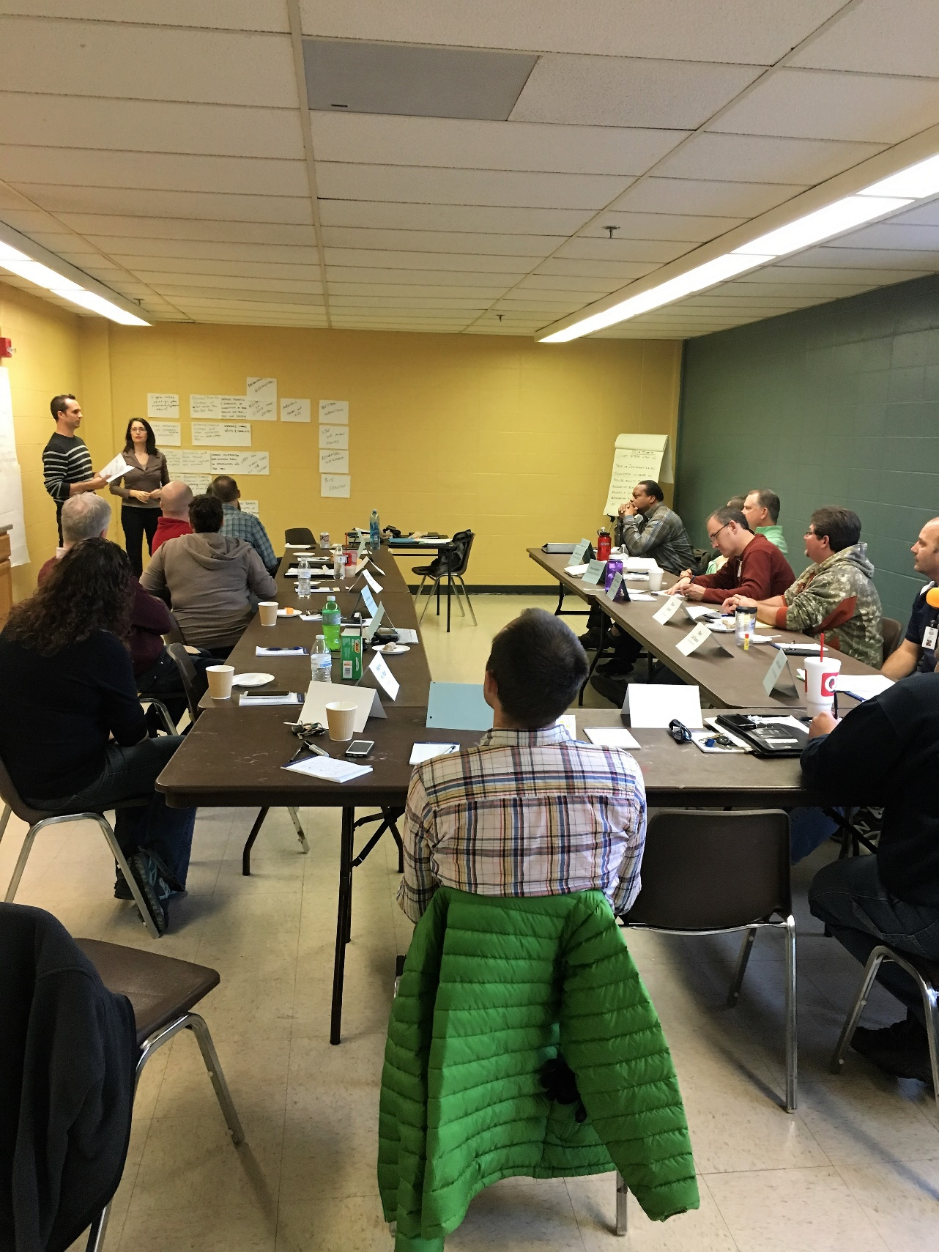

**VISIONS**

The group identified a series of visions toward which they want the department and the board to achieve.

The group determined that they wanted to develop specific actions designed to: assist in the attainment of the visions; and/or overcome obstacles that impede progress. They came to consensus regarding individual and group actions that were identified.

Furthermore, they felt that they would develop a timetable for those actions. Actions were then assigned to both an owner of the action as well as the timeframe. It must be noted that the following calendar looks like they overloaded the first six months with many actions. However, the time frame means when they will start on the action and either complete it or have substantial completion by the end of the six-month period. The resultant visions and actions identified are:

1. ***Commit to staying current and being responsive to the changing landscape through ongoing self-examination of performance***

Outcome: To create an effective organization that aligns strategy and plan execution to best serve the Kirkwood community

Tactics:

* 1. Review/update 5 year rolling strategic plan annually
  2. Review/prioritize findings of master plan/bike pedestrian plan
  3. Merge the parks and recreation into one organization with an aligned focus
  4. Commit to annual facility assessment (audit)

|  |  |  |  |
| --- | --- | --- | --- |
| **Actions** | **By September 2017** | **Oct. 2017 Mar. 2018** | **April 2018 &**  **Beyond** |
| Meet with staff to solicit input for new ideas and concepts to improve/add to current offerings and protocols:  ***Murray,*** *Kyle, and Curt Determined complete 4/16/18* | X |  |  |
| Conduct a board goal setting workshop to align with the Kirkwood P&R strategic plan: Combine with next two actions  ***Scott Stream,*** *Steve Coates, and Murray* | X |  |  |
| First annual review board’s goals during first meeting with new board members: Combined with next action  ***Board Executive Committee*** |  |  | X |
| Continue review of board’s goals during first meeting with new board members: To be completed July, 2018. Then every six months  ***Board Executive Committee*** |  |  | X |

1. ***To assure user satisfaction and provide quality leisure activity experiences through the provision of human resources and tools.***

Outcome: To accurately forecast and acquire sufficient resources to meet the needs of the Kirkwood community.

Tactics:

1. Maintain proper staffing levels commensurate with anticipated growth in parks and recreation services and facilities
2. Hire and maintain quality talent
3. Augment programmatic needs through increased use of trained volunteers
4. Improving individual performance recognition and evaluation of goals and achievements
5. Improve natural environments in the park system
6. Evaluate accessibility options to increase users throughout the park system

|  |  |  |  |
| --- | --- | --- | --- |
| **Actions** | **By Sept. 2017** | **Oct.2017 – Mar. 2018** | **April 2018 & Beyond** |
| Improve trails wayfinding, interpretation, and education outreach in outer parks: Examine opportunities for additional wayfinding at Emmenegger and Greentree. Look for additional interpretive opportunities for Greentree wetlands  ***Curt****,**Ron, and Alan* | X |  |  |
| Conduct a manpower study to determine needs to deliver on the plan (i.e. staff augmentation and /or partnerships with volunteers: Continue research on manpower needs utilizing NRPA resources  ***Pete****, Curt, and David* | X |  |  |
| Initiate an effort to establish clear areas of responsibilities and assign roles/jobs accordingly: Hold discussions with staff during staff meetings and determine what issues are.  ***Kyle*** *and Tom* |  | X |  |

***Steve Coates to examine opportunities to add action(s) regarding Tactic E.***

1. ***To stay current with ongoing societal changes that may impact facility and staff safety.***

Outcome: To preserve safety for both users and staff.

|  |  |  |  |
| --- | --- | --- | --- |
| **Actions** | **By Sept. 2017** | **Oct. 2017- Mar. 2018** | **April**  **2018 & Beyond** |
| Review larger safety trends and apply findings to Kirkwood park system:  ***Curt,*** *Wallace, Ron, and Kyle Replace Wallace with Dave H. Continue with effort to identify issues.* |  | X |  |
| Develop a training program based upon adjustments indicated by safety needs assessment:  ***Kyle*** *and Curt* |  | X |  |
| Determine if a need exists to alter/calibrate ranger hours for peak park coverage:  ***Ron*** |  | X |  |
| Implement modified safety training across Kirkwood P&R |  |  | X |
| Implement ranger coverage plan across Kirkwood P&R |  |  | X |

1. ***To maximize the use and support of all park and recreation services through improved communication and expansion of the Kirkwood P&R brand***

Outcome: To improve awareness and understanding of the total park system to meet the varied needs of the Kirkwood community.

Tactics:

1. Improve marketing to increase awareness and use of facilities and parks
2. Improve promotion and awareness of connectivity of parks through trail & bike lane system
3. Expand department led outreach program to the Kirkwood community
4. Bus service
5. Improve communication with the City
6. Expand awareness, knowledge and use of the total park system

|  |  |  |  |
| --- | --- | --- | --- |
| **Actions** | **By Sept. 2017** | **Oct. 2017 – Mar. 2018** | **April 2018 & Beyond** |
| Develop larger and more diverse program offerings  ***Laura*** *and Kate Some new programs offered. Recreation staff to develop survey instrument to assess opportunities for offsite programs, particularly related to fitness* | X |  |  |
| Designate a parks and recreation staff member to be responsible for external communications: Determined to be need to keep staff informed about various operations. Will be handled at staff meetings.  ***Murray*** | X |  |  |
| Write a marketing plan: Marketing plan nearing completion. Marketing group established and ongoing ***Kyle*** | X |  |  |
| Support city’s development of a new website that will work on various platforms: Murray serving on committee working with new website designer. New website expected to be operational summer 2018  ***Don*** | X |  |  |
| Assess the need for a marketing director not realistic at this time |  |  | X |

1. ***To expand financial resources (while maintaining financial stability) to provide more services that meet the changing needs of the Kirkwood community***

Outcome: To dedicate resources to identify and successfully solicit external funding sources

Tactics:

* 1. Explore supplemental revenue generation and programming opportunities
  2. Expand the Legacy program
  3. Improve financial viability through the acquiring and using private funds
  4. Protect financial base to enable us to maintain facilities & parks

|  |  |  |  |
| --- | --- | --- | --- |
| **Actions** | **By Sept. 2017** | **Oct. 2017 - Mar. 2018** | **April 2018 & Beyond** |
| Identify needs and potential private organizations to sponsor, partner and donate: Investigation regarding sign ordinances required in order to determine potential for posting sponsor signs and banners.  *Curt and**Tom* | X |  |  |
| Investigate and research requirement to form a Kirkwood Park Foundation:  ***Scott****, ~~Wallace~~, Alan and Steve Initial research started, to continue under Scott’s leadership* | X |  |  |
| Investigate and research grant opportunities for special projects:  ***Steve*** *and Murray List of grant opportunities developed. Looking for opportunities to utilize list while continuing ongoing research on grant opportunities.* | X |  |  |
| Develop a plan based on the needs assessment and formulate a strategy to promote the partnership program:  ***Curt*** |  | X |  |
| Initiate actions based upon research and develop a timeline for operationalizing a Kirkwood Park Foundation:  ***Scott****, Wallace, and Steve See Item 2 above* |  | X |  |
| Apply for grants for special projects with relevant funding sources:  ***Steve*** *and Murray See above* |  | X |  |
| Kirkwood Park Foundation is operationalized: |  |  | X |
| Continue investigation, research and calibrate findings with future special projects: |  |  | X |

1. ***To develop and enhance partnerships with individuals and organizations that create stronger relationships***

Outcome: To advance the provision of leisure services in the Kirkwood area through mutually beneficial partnerships and sponsorships.

Tactics:

1. Grow volunteerism and engage the public in opportunities to serve and foster civic pride
2. Develop/Enhance/improve relationships with institutions such as schools/colleges and Missouri Department of Conservation.

|  |  |  |  |
| --- | --- | --- | --- |
| **Actions** | **By Sept 2017** | **Oct. 2017 – Mar. 2018** | **April 2018 & Beyond** |
| Identify staff member as an organization relationship manager to foster sustainable partnerships: determined not realistic for one person. Murray to establish a partnership working group  ***Murray*** | X |  |  |
| Identify opportunities to participate in more community wide events (not just P&R events): complete  ***Curt****, ~~Kara,~~ Laura and Ron* | X |  |  |
| Establish guidelines for participation in community wide events and for board approval: complete  ***Curt****, Kara, Kylie and Ron* |  | X |  |
| Create task force to network with organizations (i.e. schools, colleges and MDC) to strengthen cooperative partnerships: See action Item 1  ***~~Wallace~~*** *and Pete* |  | X |  |
| Based on the success of the relationship building, develop a full-time relationship manager position to run the program |  |  | X |
| Participate in community wide events |  |  | X |

**CONTRADICTIONS, IMPEDIMENTS AND ISSUES**

To develop action plans that help attain the visions, effort needs to be undertaken to quantify challenges that can impede the attainment of the vision. Only by overcoming problems, contradictions and impediments can an organization progress. The participants used the same process as outlined for Visioning to both individually and collectively identify roadblocks that interfere and determine actions that will counteract those roadblocks.

NOTE: For impediments that have no actions under them, if the impediment was complementary to a vision, the action was included only in the vision section; other impediments with no action are important ongoing concerns that staff and board recognized as worthy of notation.

1. ***Lack of alignment among pillars of leadership***
2. Lack of partnership interaction with city council
3. Inconsistent leadership buy in and alignment
4. Lack of initiative from the Kirkwood Park Board
5. Charter mandated board turnover

|  |  |  |  |
| --- | --- | --- | --- |
| **Actions** | **By Sept. 2017** | **Oct. 2017 – Mar. 2018** | **April 2018 & Beyond** |
| Provide more communication between board and staff: Murray and Sherry to ensure board members are invited to staff events, including staff meetings. Now considered ongoing  ***~~Kara~~****, Murray, Dave and Sherry* | X |  |  |
| Develop a board bench as a feeder pool for future board members to maintain continuity: Continue to look for opportunities to involve at large citizens on board subcommittees  ***~~Wallace~~****, Scott and Steve* |  | X |  |

1. ***Attitudinal challenges***
2. Inadequate adaptation to younger generational attitude towards parks volunteerism
3. Nimbyism (Not in My Backyard)
4. Resistance to change, “We never have done that before; If it ain’t broke don’t fix it”
5. ***Inability to respond to communication trends***
6. Outdated, non-user friendly website (communication tools could be more engaging and modern)
7. Internal communication is perceived as a low priority

|  |  |  |  |
| --- | --- | --- | --- |
| **Actions** | **By Sept 2017** | **Oct. 2017 – Mar. 2018** | **April 2018 & Beyond** |
| Conduct more frequent joint staff meetings (monthly) of both parks and recreation: Staff meetings are being held on a bimonthly basis. Complete  ***Murray*** | X |  |  |
| Designate a parks and recreation staff member to be responsible for communications: Not clear what is implied by this action.  ***Murray*** | X |  |  |

1. ***Staffing challenges***
2. Staffing expertise doesn’t always match job expectations (marketing/promotion communication/safety, development direction)
3. Unclear roles and responsibilities of staff impedes productivity
4. Inadequate staff/volunteers to deliver on projects and goals
5. Lack of staff training inhibits meeting citizens’ expectations of staff as expert leaders and resources
6. Staff turnover leads to lost institutional knowledge

|  |  |  |  |
| --- | --- | --- | --- |
| **Actions** | **By Sept 2017** | **Oct. 2017 – Mar. 2018** | **April 2018 and Beyond** |
| Discuss and develop a succession plan including an examination of staff credentials: Murray has developed succession plan and reviewed with current position holders. Plan to be presented to board members  ***Murray*** *and Scott* |  | X |  |
| Examine staff credentials for efficacy in role and adjust roles and responsibilities as appropriate: Review of all job descriptions has been completed. City job/salary study involving review of job duties near completion.  ***Murray*** *and Tom* |  | X |  |

1. ***Partner Constraints***
   1. Limited response from possible cooperating agencies/partners to forming a coalition
   2. Poor relationships with some established partner agencies
2. ***Funding Challenges***
   1. Long lead time to budget for programs (missed window of opportunity for “pop up” programming to respond promptly to trends)
   2. Shift in funding levels could change coupled with increased costs could impede service levels
   3. Internal competition for existing funding levels
3. ***Regulation***
4. Regulations (city/county/state/federal) may dampen ability deliver programs as designed

|  |  |  |  |
| --- | --- | --- | --- |
| **Actions** | **By Sept 2017** | **Oct. 2017 – Mar. 2018** | **April 2018 & Beyond** |
| Identify relevant discussion items for a productive conversation with city/county/state and federal officials (i.e. internet sales tax): some conversations have been taking place regarding and identifying some issues  ***~~Wallace~~****and Scott* | X |  |  |
| Open a conversation with city/county/state and federal officials as applicable regarding issues of mutual concern (i.e. internet sales tax):  ***~~Wallace~~*** *and Scott see above. Board members encouraged to participate in MPRA legislative action day.* | X |  |  |
| Monitor any shifts in rules, regulations and codes that may apply to leisure service delivery system |  |  | X |

**ACTION PLAN IMPLEMENTATION BRIEF**

**Action Plan: ________________________________________________________________________________________**

**Vision/Contradiction: ________________________________________________________________________________**

__________________________________________________________________________________________________

__________________________________________________________________________________________________

**Who’s Responsible: _________________________________________________________________________________**

**IMPLEMENTATION STEPS:**

What tasks are necessary to either accomplish or obtain substantial progress on this action plan? When is the target date to have each of these tasks done? Who is responsible for each task? Remember some tasks may need to be accomplished first before a succeeding task can be begun. List tasks in chronological order to be done.

Description of Task When Who

1.

2.

3.

4.

5.

6.

**OUTCOME**

Upon completion of the above tasks, the desired outcome will be: ________________________________________________________________________________________________________________________________________________________________________________________________________________________________________________________________________________________________________________________________________________________________________________________________________