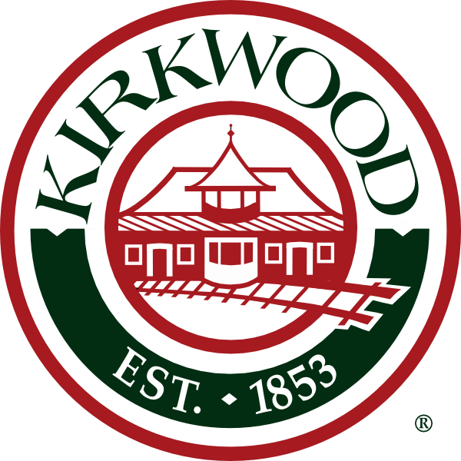

# KIRKWOOD LANDMARKS COMMISSION

## Meeting Notice

A Subcommittee of the Landmarks Commission will meet on Wednesday, September 25, 2019 at 9:30 a.m. in the Lower Level Conference Room at City Hall regarding revisions to the Landmarks Ordinance.