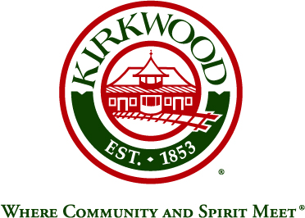
For more information, contact: Beth von Behren
Public Information Officer, City of Kirkwood
139 S. Kirkwood Road, Kirkwood, Missouri 63122
314-822-5894 or 314-495-7382 (cell)

For Immediate Release

Barb Byerly Will Serve as Grand Marshal for
Annual Kirkwood Greentree Festival Parade

July 30, 2026

Kirkwood, Missouri: Barbara J. Byerly has been selected to serve as the Grand Marshal for the 2019 Greentree Festival Parade on Saturday, September 14. Ms. Byerly is a past Kirkwood City Council member, who served the City from 1992 to 1996 and 1998 to 2000. She also served on the City’s Library Board and Greentree Festival Committee, including a term as president of both, and on the City’s Park Board, where she served as Vice President.

Ms. Byerly has been honored by the Kirkwood-Des Peres Chamber with “Kirkwood Citizen of the Year” and “Kirkwood Lifetime Achievement” awards.

She has been an active member of the community in dozens of capacities for many years, including serving on the boards of STAGES St. Louis, Manor Grove, Parents as Teachers, SSM St. Clare Medical Center, the Kirkwood School District R-7 Foundation, and the Historic Kirkwood Train Station Foundation.

Ms. Byerly has been an active member of the St. Louis County and State of Missouri Municipal Leagues, Kirkwood Rotary Club (President), Kirkwood-Des Peres Chamber (President), First Presbyterian Church (Sesquicentennial Celebration Chair; Deacon), and as a volunteer for the Earl and Myrtle Walker Scottish-Rite Clinic (Gala Committee Member) and SSM St. Joseph Hospital of Kirkwood (Golf Tournament Committee Member; 50th Anniversary Celebration Co-Chair).

Professionally, Ms. Byerly is a former Executive Director of the Kirkwood Special Business District and owns and operates her own public relations firm, BJB Creative Services.

The theme for this year’s Greentree Festival is “Let the Board Games Begin.” The parade will step off at 10:00 a.m., on Saturday, September 14, and the festival will run for three days, September 13, 14, and 15, in Kirkwood Park during these hours:

- Friday, September 13: 5:00 to 10:00 p.m.
- Saturday, September 14: 9:00 a.m. to 7:00 p.m.
- Sunday, September 15: 10:00 a.m. to 5:00 p.m.

###

