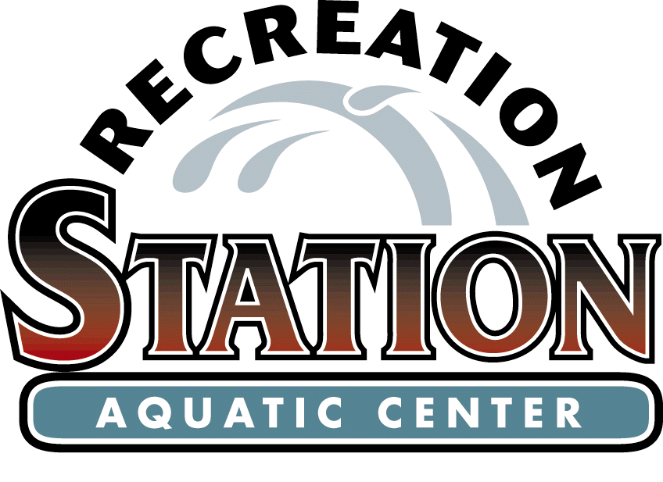
Glendale/Kirkwood/Oakland
Aquatic Advisory Committee Agenda
July 8 , 2019, 6:45 p.m.
Aquatic Center

- Citizen Comments

- Approval of the May 13, 2019 Meeting Minutes

- Superintendent’s Report

- Financials as of July 8, 2019

- Kiddie Pool

- Lifeguards Unlimited to Midwest Pool Management Contract

- Old Business

- New Business

- Committee Comments

- Next Meeting – August 12, 2019

THE CITY OF KIRKWOOD IS INTERESTED IN EFFECTIVE COMMUNICATION FOR ALL PERSONS. PERSONS REQUIRING AN ACCOMMODATION TO ATTEND AND PARTICIPATE IN THE MEETING SHOULD CONTACT THE PARKS AND RECREATION OFFICE AT 314-822-5855 AT LEAST 48 HOURS BEFORE THE MEETING. WITH ADVANCE NOTICE OF SEVEN CALENDAR DAYS, THE CITY OF KIRKWOOD WILL PROVIDE INTERPRETER SERVICES AT PUBLIC MEETINGS FOR LANGUAGES OTHER THAN ENGLISH AND FOR THE HEARING IMPAIRED. UPON REQUEST, THE MINUTES FROM THIS MEETING CAN BE MADE AVAILABLE IN AN ALTERNATE FORMAT, SUCH AS CD BY CALLING 314-822-5802.

