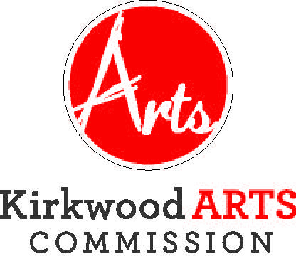

KIRKWOOD ARTS COMMISSION

TUESDAY, JUNE 25, 2019, 5:00 P.M.
KIRKWOOD COMMUNITY CENTER, 111 S. GEYER ROAD, ROOM 202
AGENDA
- CITIZEN COMMENTS (3 minute time limit. The public comment portion of the meeting is an opportunity to listen to comments from citizens. It is not a question and answer session and the Commission will not respond to comments or answer questions during the comment period. The Chairperson may refer any matter to staff or hold discussion during the “Other Matters” section of the meeting).
- APPROVAL OF MAY 21, 2019 MEETING MINUTES
- INTRODUCTION OF NEW COMMISSION MEMBERS
- COMMITTEE REPORTS
- Public Art
  - Sculpture on the Move
  - Photo Contest
- Art at the Station
- Making Music Concerts
- Kirkwood Arts Foundation
- UNFINISHED BUSINESS
- Strategic Planning Update
- Cars and Guitars Event
- Greentree Festival Participation

- NEW BUSINESS
a) Performing Arts Center Mural Project
b) Future Meeting Dates
b) Other Matters
- ADJOURNMENT
The City of Kirkwood is interested in effective communication for all persons. Persons requiring an accommodation to attend and participate in the meeting should contact the Director of Parks and Recreation at 314-822-5855 at least 48 hours before the meeting. With advance notice of seven calendar days, the City of Kirkwood will provide interpreter services at public meetings for languages other than English and for the hearing impaired. Upon request, the minutes from this meeting can be made available in an alternate format, such as cd by calling 314-822-5857. Next meeting date to be determined.

