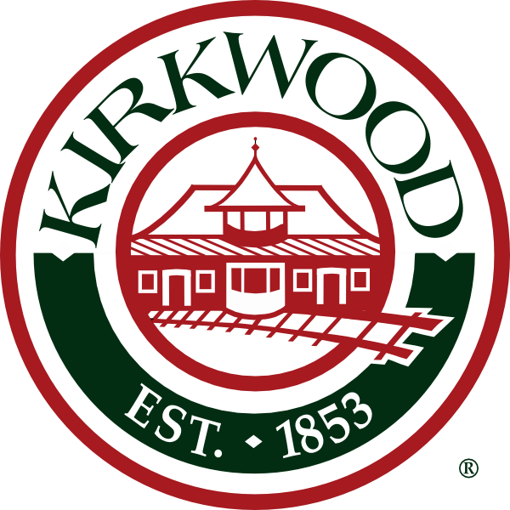

# KIRKWOOD LANDMARKS COMMISSION

## AGENDA

**Wednesday, June 12, 2019 at 7:00 p.m. Kirkwood City Hall**

**City Council Chambers**

1. **Approval of Minutes of April 10, 2019** and any additions or modifications to the current agenda.
2. **Certificate of Appropriateness**
   1. **Case #07-19, 518 Scottsdale Rd.** (Landmark #69, How Farm) – Demolition of home
   2. **Case #19-17 Amended, 326 E. Jefferson Avenue** (Jefferson-Argonne Historic District) – Substitution of wrought iron hand rails for wood on new home.
3. **New Business**
   1. Citizens Comments/Seeking Advice to preserve their historic properties
4. **Old Business**
   1. Update on ongoing projects
5. **Adjourn**

Persons who need accommodations to attend or participate in the meeting should call the City Clerk at 822-5802 at least 48 hours before the meeting.