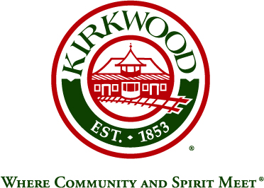
For more information, contact: Beth von Behren
Public Information Officer, City of Kirkwood
139 S. Kirkwood Road, Kirkwood, Missouri 63122
314-822-5894 or 314-495-7382 (cell)

For Immediate Release

Kirkwood Kicks Off Comprehensive Code Update Project

July 29, 2026

Kirkwood, Missouri: The City of Kirkwood has kicked off a comprehensive update of the codes that regulate development throughout the City. Called “Kirkwood by Design,” the development code update is an early step toward implementing the vision expressed through community planning efforts such as the EnVision Kirkwood 2035 Comprehensive Plan and the Downtown Master Plan.

The City has hired Development Strategies and Compass Point Planning to update the City’s codes for zoning, subdivision, signs, and architectural review. These codes regulate how development occurs in residential neighborhoods and commercial districts.

The effort kicked off in early May with two days of stakeholder interviews and a meeting with a steering committee of City Council and Planning and Zoning Commission members. Residents will have multiple opportunities to provide feedback on the proposed changes through traditional public meetings and a series of short online surveys.

The first survey on residential construction and accessory dwelling units (“granny flats”) is now available on the project website at www.kirkwoodbydesign.com or by going directly to the following link: https://www.surveymonkey.com/r/KirkwoodResidential1. On the site, residents will also be able to track the project and sign up for email updates. The first public meeting will take place on Thursday, June 27 (exact time and location to be determined). The City’s consultant will make available information from a Code Diagnosis Report at that time, which is a high-level review of recommended changes. Any feedback or input from the community will be considered before drafting any major changes to the City’s Code.

###

