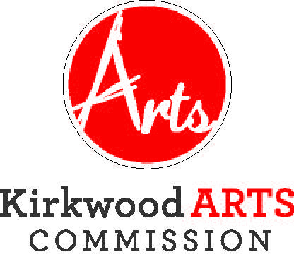

KIRKWOOD ARTS COMMISSION
PUBLIC ART SUBCOMMITTEE

THURSDAY, MAY 23, 2019
KIRKWOOD COMMUNITY CENTER, 111 S. GEYER ROAD, ROOM 302
5:15 P.M.
AGENDA
- APPROVAL OF FEBRUARY 27, 2019 MEETING MINUTES
- UNFINISHED BUSINESS
- Photo Competition Update
- Sculpture on the Move Update

- NEW BUSINESS
- Strategic Plan Implementation
  - Develop Priority List of Arts Projects
  - Develop List of Potential Locations for Art
  - Develop Maintenance Plan for Public Sculpture Pieces
- Other Matters
- ADJOURNMENT

The City of Kirkwood is interested in effective communication for all persons. Persons requiring an accommodation to attend and participate in the meeting should contact the Director of Parks and Recreation at 314-822-5855 at least 48 hours before the meeting. With advance notice of seven calendar days, the City of Kirkwood will provide interpreter services at public meetings for languages other than English and for the hearing impaired. Upon request, the minutes from this meeting can be made available in an alternate format, such as cd by calling 314-822-5857.

