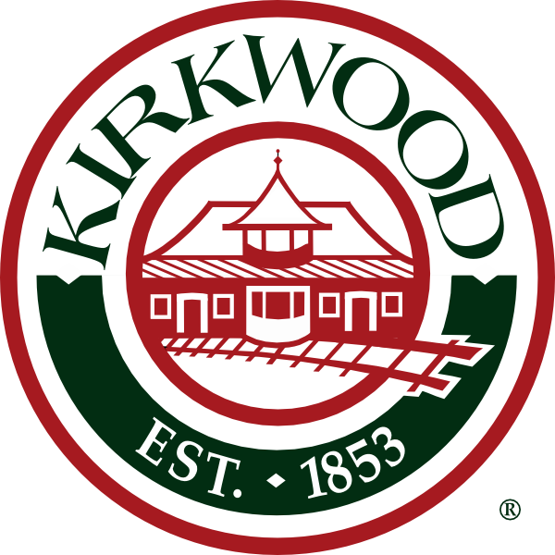
Agenda
Architectural Review Board
City of Kirkwood
Date: May 20, 2019
Place: City Hall Council Chambers
Time: 7:00 P.M.

Approval of Minutes: May 6, 2019

Sign Review – Old Business

Case No. 13-19S – 124 W. Monroe Ave – Anic Enterprises – Zoning B-2 – Pfitzinger Graphics, applicant. Install one (1) double sided ground sign 38”x60”. Total new signage 31.60 sq. ft.

Sign Review - New Business

Case No. 14-19S – 124 W. Jefferson Ave. Ste. 101 – Guaranteed Rate, Zoning B-2 – Sign-A-Rama, applicant. Install one(1) wall sign 33”x120” = 27.5 sq. ft. Total signage = 27.5 sq.ft.

Residential Review - New Business

Case No. 65-19R – 600 N. Taylor Ave. – Zoning R-3 – John Odom, applicant. Addition of a pool bathroom.

Case No. 66-19R – 670 W. Washington Ave. Zoning 4 – Lewis Homes, applicant. New single family residence

Case No. 67-19R – 115 Gilbert St. – Zoning R-3 – Kristen Jockenhoefer, applicant. Garage and master suite addition

Case No. 68-19R – 1012 Whitecliff – Zoning R-3 – John Sunderman, applicant. New addition

Commercial Review – New Business

Case No. 05-19C – 204 S Clay Ave. – New condo complex – Zoning B-2 – Amanda Norris w/ Core 10 Architecture, applicant. New condo complex

Case No. 06-19C – 10764 Manchester Rd – Kirkwood Fence – Zoning B-3 – Brian Ivy, applicant. New front facade

C: Bill Bensing, Director of Public Services,
Laurie Asche, City Clerk
Fredrick Doss, Deputy City Clerk
Tim Griffin, Mayor
Kara Wurtz, Liaison
Donna Poe, SBD
Elizabeth von Behren, Public Information Officer
Jonathan Raiche, City Planner
Amy Lowry, Landmarks Liaison

The city of Kirkwood is interested in effective communication for all persons. Persons requiring an accommodation to attend and participate in the meeting should contact the building commissioner’s office at 314-822-5816 at least 48 hours before the meeting. With advance notice of seven calendar days, the city of Kirkwood will provide interpreter services at public meetings for languages other than English and for the hearing impaired. Upon request, the minutes from this meeting can be made available in an alternate format, such as cd by calling 314-822-5816.

