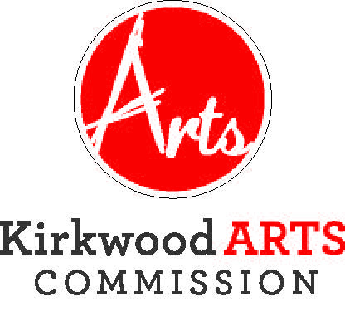

KIRKWOOD ARTS COMMISSION

TUESDAY, APRIL 16, 2019, 4:30 P.M.
KIRKWOOD COMMUNITY CENTER, 111 S. GEYER ROAD, ROOM 302
AGENDA
- CITIZEN COMMENTS (3 minute time limit. The public comment portion of the meeting is an opportunity to listen to comments from citizens. It is not a question and answer session and the Commission will not respond to comments or answer questions during the comment period. The Chairperson may refer any matter to staff or hold discussion during the “Other Matters” section of the meeting).
- Strategic Planning Session
- APPROVAL OF FEBRUARY 19, 2018 MEETING MINUTES
- COMMITTEE REPORTS
- Sculpture on the Move
- Photo Contest
- Art at the Station
- Making Music Concerts
- Kirkwood Arts Foundation
- UNFINISHED BUSINESS
- Recruitment of Additional Commission Members
- Sculpture on the Move Locations
- Cars and guitars Event and Sculpture

- NEW BUSINESS
a) None
b) Other Matters
- ADJOURNMENT
The City of Kirkwood is interested in effective communication for all persons. Persons requiring an accommodation to attend and participate in the meeting should contact the Director of Parks and Recreation at 314-822-5855 at least 48 hours before the meeting. With advance notice of seven calendar days, the City of Kirkwood will provide interpreter services at public meetings for languages other than English and for the hearing impaired. Upon request, the minutes from this meeting can be made available in an alternate format, such as cd by calling 314-822-5857. Next meeting scheduled for Tuesday, May 20, 2019.

