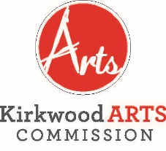

KIRKWOOD ARTS COMMISSION
MAKING MUSIC SUBCOMMITTEE

MONDAY, APRIL 8, 2019
KIRKWOOD COMMUNITY CENTER, 111 S. GEYER ROAD, ROOM 202
5:00 P.M.
AGENDA
- APPROVAL OF MARCH 11, 2019 MEETING MINUTES
- NEW BUSINESS
a. Introduction of new subcommittee member Amy Studt.
b. Distribution of concert series programs and cards.
c. Discussion of placement of concert series programs and cards.
d. Discussion of advertising efforts for May 4 Spring Kickoff concert.
- ADJOURNMENT

The City of Kirkwood is interested in effective communication for all persons. Persons requiring an accommodation to attend and participate in the meeting should contact the Director of Parks and Recreation at 314-822-5855 at least 48 hours before the meeting. With advance notice of seven calendar days, the City of Kirkwood will provide interpreter services at public meetings for languages other than English and for the hearing impaired. Upon request, the minutes from this meeting can be made available in an alternate format, such as cd by calling 314-822-5857.

