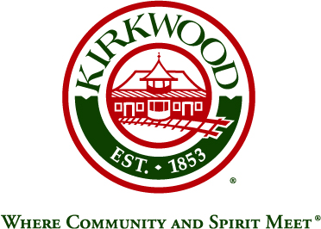
For more information, contact: Beth von Behren
Public Information Officer, City of Kirkwood
139 S. Kirkwood Road, Kirkwood, Missouri 63122
314-822-5894 or 314-495-7382 (cell)

For Immediate Release

Kirkwood Will Hold Public Information Meeting on Merger Proposal

July 31, 2026

Kirkwood, Missouri: The City of Kirkwood will hold a Public Information Meeting on the proposed City-County merger. This will be an opportunity for residents to receive information and facts about the proposal. It will be structured in a question-and-answer format between the public and City of Kirkwood Council members and staff.

The public is encouraged to attend.

Details:
- Tuesday, March 26, 2019, 7:00 p.m.
- Reim Theatre, Kirkwood Community Center, 111 S. Geyer Road, 63122

###

