**WHAT YOU NEED TO KNOW ABOUT THE CITY’S NEW TREE ORDINANCE**

**What is a “public” tree vs a “private” tree?**

Private trees are located on private property. Public trees are located in the City’s right-of-way (ROW) areas. Typically, but not always, this means in the area at the front of a dwelling or business, in the space between the curb and the sidewalk. When there’s no sidewalk, the ROW extends into the front yard of the property. To be certain, property owners can consult the title drawing they received when they purchased the property. The Kirkwood City Map located on the City’s website also shows property lines and ROW areas. (See instructions, right.)

**Instructions for using the Kirkwood Base Map on the City website:**

To access the ROW markings on the City’s online map, visit www.kirkwoodmo.org/citymap, choose the “Kirkwood Base Map,” and then find your property by typing in the address in the “Find address or place” search bar in the upper right-hand corner. You can also click on the “target” icon, below the plus/minus icons on the left side, and it will zoom in on your location. Then turn on the aerial view. You can find this in two places: 1) Under layers on the right side. 2) Using the base map icon located at the top of the map on the left side. This icon looks like a block of four squares. Once in aerial view, you will be able to see where the trees on your property are and if they fall within the right-of-way area or not. You can use the zoom keys to zoom in and out or use your mouse to do the same.

**What are my responsibilities as a property owner?**

**Regular Maintenance:** Property owners are responsible for clearance pruning of public and private trees, as outlined in the Nuisance Code. These requirements are:

* Trees must be trimmed to a minimum of 7 feet above sidewalks or walkways.
* There must be a minimum height and vertical clearance of 12 feet at the curb line on the street and a vertical clearance of 14 feet above the center of the traffic lane.
* There must be a clear line of sight for at least 75 feet on the approach to all traffic signals or signs.

**Storm Clean-Up:**  When limbs or debris from trees  
on private property fall into the street in the City,  
the property owner is responsible for disposal of  
the debris. Kirkwood crews will clear the street and move the debris onto the homeowner’s property  
for disposal. If a tree located in the “right-of-way” falls during a storm, the City of Kirkwood will remove the fallen tree and clean up the mess. In some instances, where storm damage is wide-spread and the costs will be reimbursed through federal and state agencies such as FEMA, Kirkwood’s City Council may decide to clean up and dispose of debris, but City crews are otherwise not authorized to dispose of storm-related debris on private property. Notification of any such City Council decision would appear on the City’s website.

**Do I need a permit to take down a diseased or dead tree?**

No. No permit is required to take down a tree for any reason on private property.

**What about trees on the ROW – do I need a permit to take those down?**

Yes. To take down or perform any maintenance above the responsibilities outlined in the Nuisance Code (as outlined above), a permit must be obtained from the City’s Urban Forester.

**Do I need to plant trees to comply with the new ordinance?**

No. The requirement to have a “tree canopy” that occupies 35 percent of a piece of property only applies to the following:

1. New home construction.
2. Work being done to an existing property that requires a building permit, such as an addition or an accessory structure, e.g., a detached garage or a pool. When the permit process is triggered, the property owner will be required to comply with the 35-percent canopy requirement. If you are planning an addition or other major changes to your property, please consult with the City Planner to learn about all requirements involved with your project. Call 314-984-5926.
3. 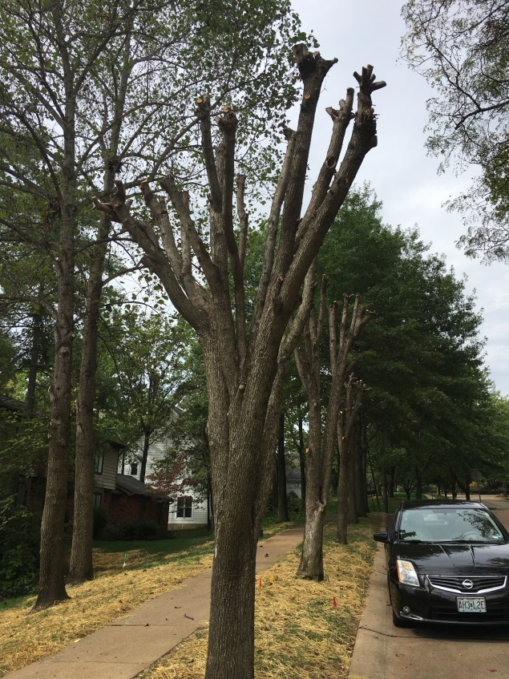Fence, driveway, or sewer lateral permits are required to meet tree protection requirements only.

The Tree Ordinance is not intended to be burdensome to homeowners or commercial property owners.

**What other rules apply to City ROW trees?**

Maintenance: if the property owner plans to trim trees above the clearance requirements (see above), he or she must submit a Tree Maintenance Permit Application. This does not apply to trees on private property outside of the ROW.

**How much pruning is too much?**

Pruning beyond the clearance requirements is too much without a permit. For example, heading cuts or “topping” of trees, tree removal, or thinning of trees located in the City’s ROW is restricted. Here is an example of what “topping” or heading cuts look like (photo, right).

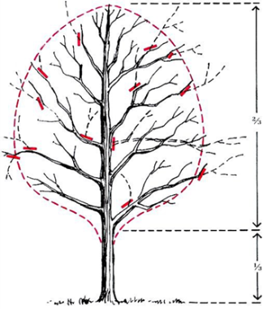

The graphic indicates the correct way to prune.

**Additional questions? Contact the City’s Urban Forester, Cory Meyer:**

* Email: Meyercc@kirkwoodmo.org
* Phone: 314-984-5907

Want to read the Tree Ordinance? You can find it on the City website at:  
www.kirkwoodmo.org/UrbanForestry