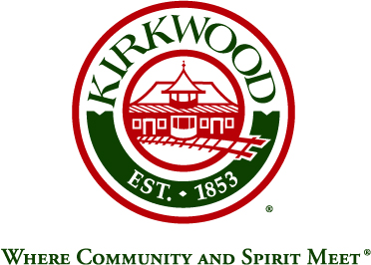
For more information, contact: Beth von Behren
Public Information Officer, City of Kirkwood
139 S. Kirkwood Road, Kirkwood, Missouri 63122
314-822-5894 or 314-495-7382 (cell)

For Immediate Release

Kirkwood Greentree Festival Parade Theme for 2018 is:
Greentree Rock ‘n Roll 2018

August 21, 2018

Kirkwood, Missouri: The Kirkwood Greentree Festival’s signature parade will be held on Saturday, September 15, through downtown Kirkwood. This year’s theme is: Greentree Rock ‘n Roll 2018, and this year’s Grand Marshal is retiring Kirkwood City Clerk Betty Montano.

Betty Montano came to work for the City of Kirkwood in 1988 and has served as City Clerk for the last 23 years. She will retire on September 7, 2018. As City Clerk, she has served as the liaison between the City’s Mayor, Council, staff, and citizens. She answers questions, helps to resolve concerns, fulfills records requests, and handles an assortment of other duties. Betty has also been active in her profession. She served as President of the Missouri City Clerks and Finance Officers for both the Eastern Division and the State of Missouri.

The main sponsor of this year’s parade is The Allen Brake Team. Co-sponsors are Suntrup Ford Kirkwood and PJ’s Tavern

The parade will step off at 10:00 a.m. on the 15th, from Kirkwood High School, 801 West Essex, and will conclude no later than noon.

Parade Route: The parade starts on West Essex and travels east, turning south on Kirkwood Road and heading to West Argonne. It runs west at Argonne toward Geyer Road, where the parade ends at the Community Center parking lot.

Road Closures: Kirkwood Police will close the following streets during the parade:
- Kirkwood Road from Monroe north to Jewel Avenue
- West Essex from Kirkwood Road west to Chopin
- West Argonne from Kirkwood Road west to Geyer Road

Taylor Avenue east of Kirkwood Road will be the detour route. Signs will be posted, and the affected streets will reopen as soon as the parade ends.

###

