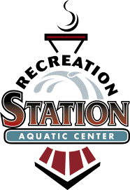

**AQUATIC**

**ADVISORY COMMITTEE**

**MEETING MINUTES**

**Glendale/Kirkwood/Oakland**

**111 South Geyer Road**

**Kirkwood MO 63122**

**February 12th at 6:45PM**

**Present:** Members:Natalie Bolten, Bill Riggs, Landy Wedlock, Kelli Ivy, Aaron Cole

Staff Liaison: Kyle Henke LU: Hannah

1. **Citizen Comments:**
2. N/A
3. **Approval of the January 8th 2018 Meeting Minutes**
4. Motion 1st by Kelly and 2nd by Landy
5. **Superintendent’s Report**
   1. Financials as of February
6. Stone Pillars
7. Pool Painting
8. Fence Painting
9. Locker Room Painting
10. Locker Room Floor Cleaning
11. VGB Grates
12. Aquatic Facility Audit
13. Skimmer Repair
14. Electric in Pump Room
    1. ***Under Budget for all repairs***
15. **Old Business**
    1. Concession
16. **New Business**
    1. LGU; Staffing for Kirkwood is coming along well
    2. Lifeguard classes at Kirkwood HS has been a part of their gen ed curriculum.

1. **Committee Comments**
   1. None
2. **Next Meeting – April 9, 2018 – 6:45 p.m.**
3. **Meeting adjourned by: 1st Bill and 2nd Kelli**