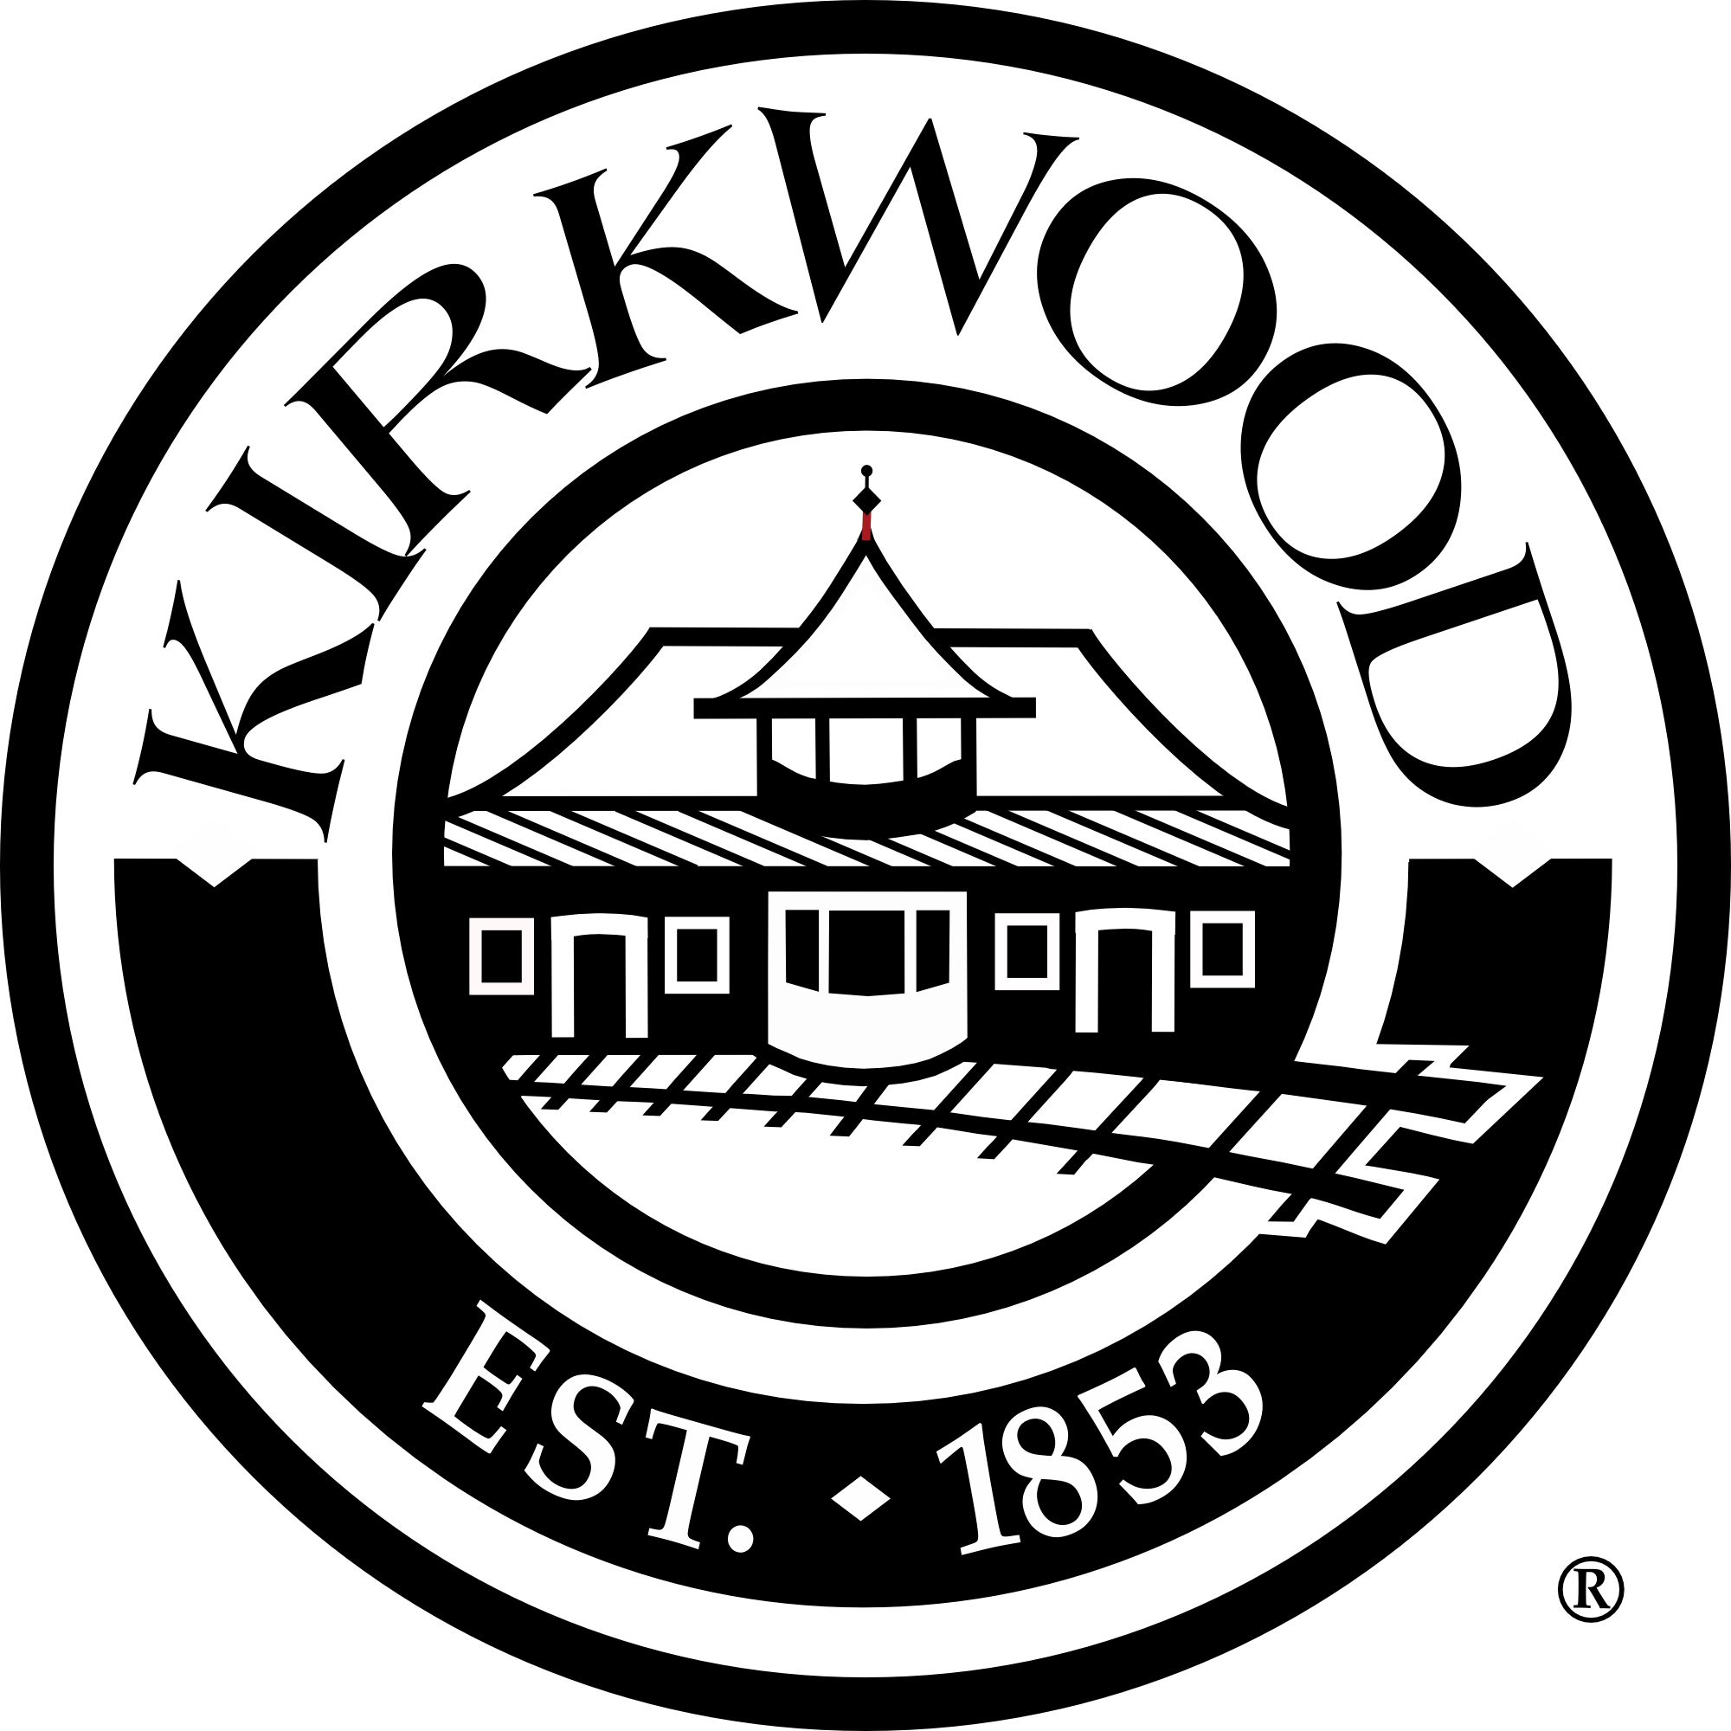
NOTICE OF PUBLIC MEETING
CITY OF KIRKWOOD:
GEYER ROAD RESURFACING – PHASE I
Manchester Road to West Adams Ave

Notice is hereby given to all interested persons that a public meeting will be held in City Council Chambers of City Hall located at 139 South Kirkwood Road, Kirkwood, Missouri, 63122 on Monday, October 29, 2018, from 4:00 – 7:00 p.m. Central Standard Time. Handicap access is available. All interested persons will be given an opportunity to make comments concerning the design of the Geyer Road Resurfacing – Phase I Project. The presently contemplated improvement/project is as follows:

- 2” Coldmilling of Existing Asphalt Surface
- New 2” Asphalt Overlay
- Spot Curb Repairs as indicated on the plans
- Repair of Existing Sidewalk Trip Hazards as indicated on the plans
- Americans with Disabilities Act (ADA) Compliant Curb Ramps
- New Pedestrian Crosswalk with Pedestrian Hybrid Beacon at Keysor Elementary School
- Bicycle Facility Markings
- Minor Storm Sewer Adjustments and Modifications
- Minor Utility Adjustments
- Minor Drainage Adjustments
- Spot Driveway Reconstruction as indicated on the plans
- New Permanent Easements as indicated on plans
- Temporary Construction Easements as indicated on plans
- Removal of Improvements as indicated on plans

Preliminary plans, maps, environmental documentation, and other detailed information prepared by the City of Kirkwood’s engineering consultant (Bax Engineering Co.) will be available at the public meeting and are also available for public viewing and copying at the office of the Public Services Department; 139 South Kirkwood Road, St. Louis, Missouri, 63122.

Tentative schedules for right of way acquisition and construction will be discussed at the open house-style format.

If you are disabled and require special services at the public hearing, please notify Laurie Asche by October 26th at (314) 822-5802 so that arrangements for those services can be made.

CITY OF KIRKWOOD, PUBLIC SERVICES DEPARTMENT

