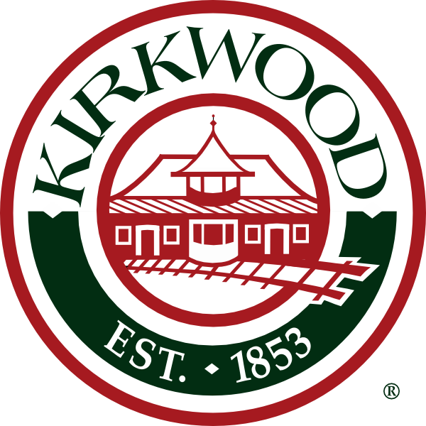

CITY OF KIRKWOOD
ARTS COMMISSION

AUGUST 16, 2022
MEETING CANCELLED

NEXT MEETING
SEPTEMBER 20, 2022
5:00 P.M.

