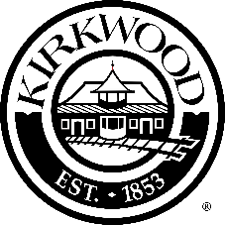

PUBLIC COMMENTS – West Essex Avenue Reconstruction Project
MoDOT Local Roads Project Number STP-5502 (610)

This form is for public comments concerning the proposed improvements along West Essex Avenue between Geyer Rd and Kirkwood Rd. All comments received will be considered in the final design of the project and will remain on public file.

For inclusion in the file, this form may be placed in the box during this meeting, emailed, or mailed. Emailed comments must be received by July 29, 2022 to holesire@kirkwoodmo.org. Mailed comments should be post marked by July 29, 2022, and addressed to:

Mr. Richard Holesinger, PE
Re: West Essex Avenue Reconstruction Project
Assistant City Engineer
139 S. Kirkwood Road
Kirkwood, MO 63122

Comments unrelated to the W Essex Avenue Reconstruction Project will not be included in the file.
===============================================================================

Name:_________________________________________________

Address:_______________________________________________

City:______________________ State:_______ Zip:___________

Phone:____________________ Email:___________________________

