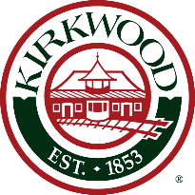

PLANNING AND ZONING COMMISSION

SUBCOMMITTEE MEETING

**TIME: 2:00 P.M.**

**DATE: FRIDAY, JUNE 17, 2022**

**LOCATION: MAIN LEVEL CONFERENCE ROOM, KIRKWOOD CITY HALL, 139 S. KIRKWOOD RD**

**AGENDA: WOODLAND HILL SUBDIVISION/COMMUNITY UNIT PLAN, 6 LOTS (PZ-1-23)**

**600 NORTH BALLAS ROAD**

**CONTACT: AMY LOWRY (314) 822-5815**

POSTED: JUNE 10, 2022