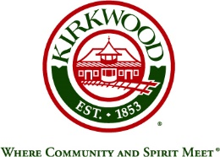

**Employee Advisory Commission**

**Agenda**

**Thursday, March 10, 2022, 9:00 a.m.**

**Kirkwood Community Center**

**Room 202**

1. Roll Call
2. Approval of February 2022 Meeting Minutes
3. Update on resolution of any pending issues – Mollie LeBlanc
4. Action on February 2022 Suggestion Box items – Mollie LeBlanc
5. Concerns since February 2022 meeting
   1. Meeting Suggestion Box
   2. LAGERS
6. Round Table Discussion by Department
7. Set Next Meeting in April , 2022, 9:00 a.m. Chair:
8. Adjourn